SAP ABAP Project Report

Project Title: Employee Leave Management System
Submitted by: Karthik S
Under the guidance of: Mr. Rajendra

A) Executive Summary
This report outlines the design, implementation, and testing of the Employee Leave Management System (ELMS) developed using SAP ABAP.
The system automates the management of employee leave records, integrating multiple ABAP components such as the Data Dictionary, Function Modules, Table Maintenance Generator (TMG), Reports, and Module Pool Programming.
This project demonstrates a full-cycle SAP ABAP implementation of employee leave management integrating all major technical components.

Introduction to SAP ABAP
SAP ABAP (Advanced Business Application Programming) is the core language used to develop applications within the SAP ecosystem.
ABAP enables customization of standard SAP modules and supports the creation of reports, user interfaces, and database management processes.
B) Employee Leave Management System
This SAP ABAP mini project demonstrates a complete Employee Leave Management System implemented using core ABAP concepts like Data Dictionary, Function Modules, Reports, and Module Pool Programming.
The project focuses on maintaining employee leave records, automating leave ID generation, and enabling CRUD operations with reporting functionality.

C)Objective
The objective of this project is to design and develop an Employee Leave Management System in SAP ABAP that allows users to:
1. Create and maintain leave records.
2. Automate leave ID generation using Function Modules.
3. Display employee leave data using ALV reports.
4. Enable table maintenance through SM30 (Table Maintenance Generator).
5. Validate data entries and provide complete CRUD functionality.

System Overview
The Employee Leave Management System is designed using a three-layer architecture:
1. Presentation Layer – Handles user inputs through reports and screens.
2. Application Layer – Manages business logic via Function Modules.
3. Database Layer – Stores leave details using a custom transparent table in the Data Dictionary.

D) Modules Implemented
- 1. Data Dictionary Objects (Table, Domains, Data Elements)
- 2. Technical Settings Configuration
- 3. Table Maintenance Generator (TMG)
- 4. Function Module: Z_FM_ELM_CREATE
- 5. Include Program: ZELM_INCL_DB
- 6. Report Program: ZELM_CREATE_UI
- 7. Module Pool Program: ZELM_MGNT
- 8. ALV Report: ZELM_RPT
- 9. Data Browser Validation (SE16N)
- 10. Testing and Output Verification

E) Implementation Details
Each module in this system serves a specific function. The Data Dictionary defines custom objects,
the Function Module automates unique ID generation, and Reports display output in structured ALV format.
The Module Pool handles user interactions while TMG provides a simple interface for maintaining entries.

Function Module - Z_FM_ELM_CREATE
This Function Module automates the process of inserting records into the ZELM_LEAVE table.
It ensures data validation and prevents duplicate Leave IDs by generating new unique identifiers.

Reports - ZELM_CREATE_UI and ZELM_RPT
The ZELM_CREATE_UI report allows users to input employee leave details, while ZELM_RPT retrieves and displays leave records using ALV grids.
Both reports use modularized code from ZELM_INCL_DB for better maintainability.

Module Pool Program - ZELM_MGNT
This program implements PBO (Process Before Output) and PAI (Process After Input) logic to create an interactive screen for leave management.
It handles data entry, validation, and user navigation efficiently.

Table Maintenance Generator (TMG)
TMG provides a simple SM30-based interface for data maintenance.
Administrators can add, modify, or delete leave records through the automatically generated maintenance screens.

Testing and Validation
Testing was performed using transactions SE11, SE16N, and SM30.
Sample data entries were created, validated, and displayed successfully.
Functionality such as record creation, modification, and deletion was confirmed through TMG.

Output Explanation
The project outputs include screenshots from SAP GUI demonstrating each module's functionality —
from table creation to data maintenance and ALV report display.
All test cases produced expected results confirming system reliability.

Results
The Employee Leave Management System achieved all objectives.
Data integrity was maintained, and business logic was accurately implemented through ABAP coding practices.

F) Tools and Environment

The Employee Leave Management System was developed and tested in the SAP ABAP environment using the following tools and system configurations:
1. Software Environment
- SAP GUI Version: SAP Logon 7.80 (or your current version)
- SAP Application Server: SAP ECC 6.0 / SAP S/4HANA 1909
- ABAP Editor Transactions Used: SE11, SE37, SE38, SE80, SE16N, SM30
- Database: SAP HANA (Integrated)
- Operating System: Windows 10 / 11 (64-bit)
- Programming Language: ABAP (Advanced Business Application Programming)
2. Hardware Requirements
- Processor: Intel Core i5 or higher
- RAM: Minimum 8 GB (Recommended 16 GB for SAP local systems)
- Storage: At least 20 GB free space for SAP environment
3. Development and Execution Environment
- Development Server: SAP ABAP Workbench (Object Navigator – SE80)
- Testing Tools: Data Browser (SE16N), Table Maintenance Generator (SM30)
- Version Control: TR Transport Requests within SAP
- Output Tools: ALV Grid Display for reports
4. User Roles
- Developer: Responsible for creating ABAP programs and Function Modules
- Administrator: Handles TMG and authorization access via SM30
- End User: Executes reports and views leave data in ALV format

G) Project Flow

- User enters leave details in Report ZELM_CREATE_UI.
- Data is passed to Function Module Z_FM_ELM_CREATE which auto-generates a unique Leave ID.
- The record is inserted into custom table ZELM_LEAVE.
- Admins can maintain records via Table Maintenance Generator (SM30).
- Employees and HR can view data via ALV Report ZELM_RPT.
- Module Pool ZELM_MGNT handles screen interactions and validations.

System Architecture
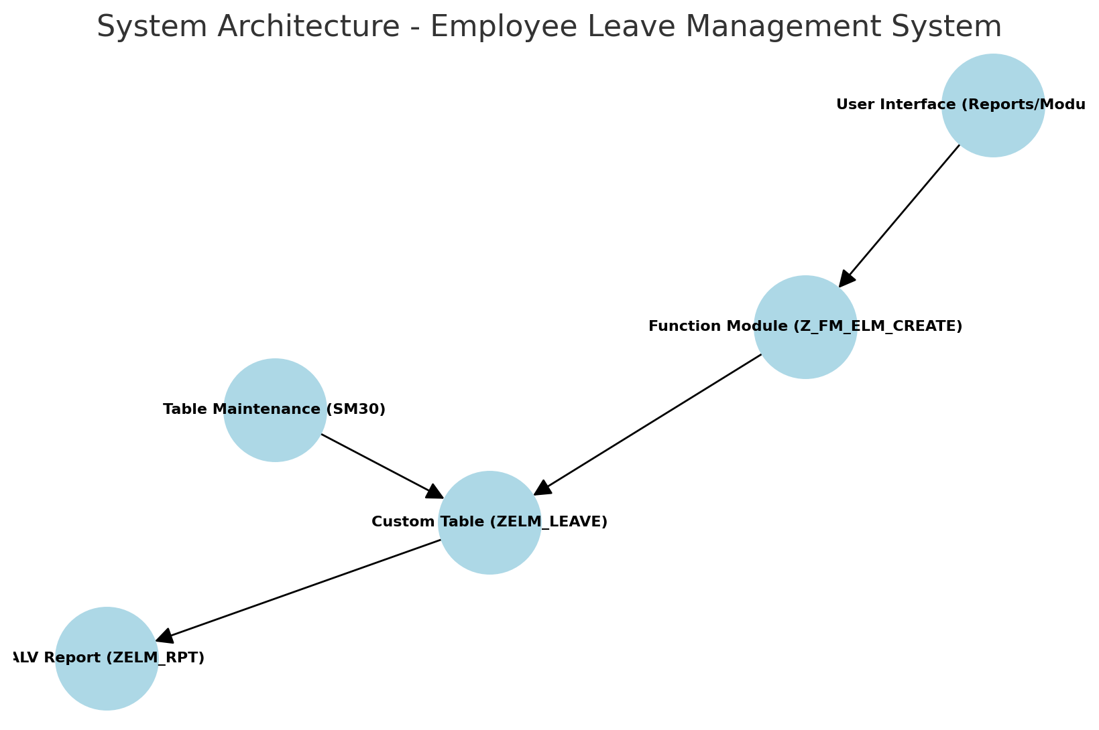
This diagram shows the three-tier architecture: UI, Function Module, and Database integration.

Data Flow Diagram (Level 0)
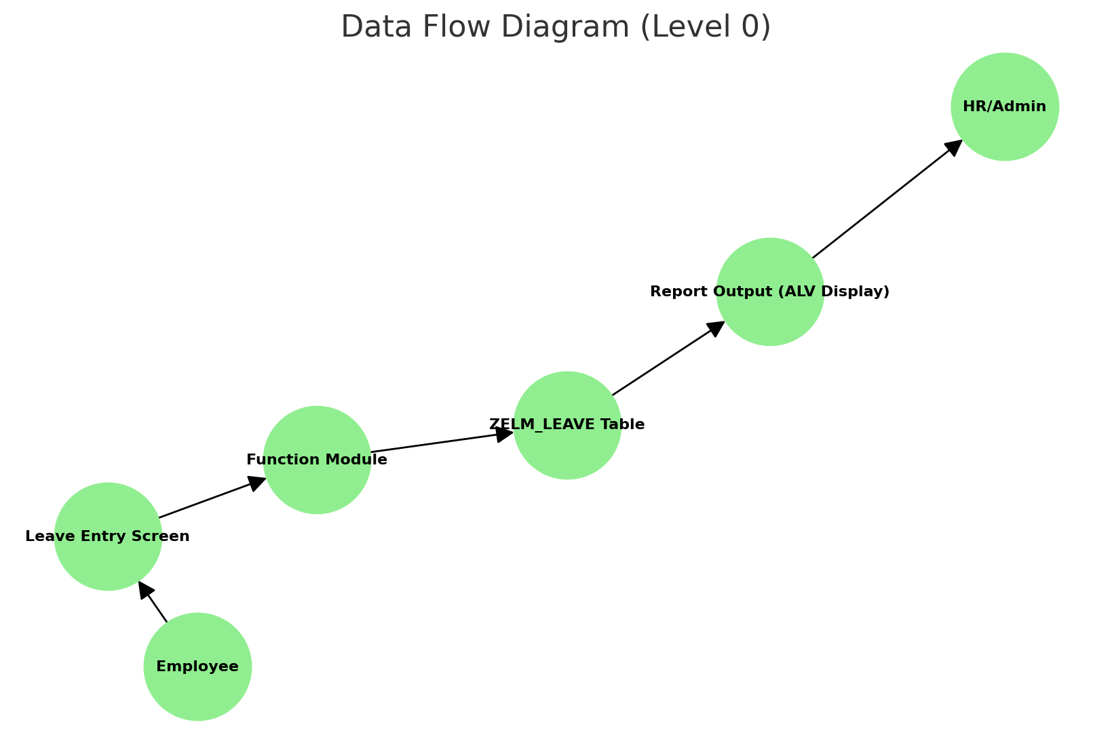
Depicts how employee data moves through modules from entry to reporting.

Entity Relationship Diagram
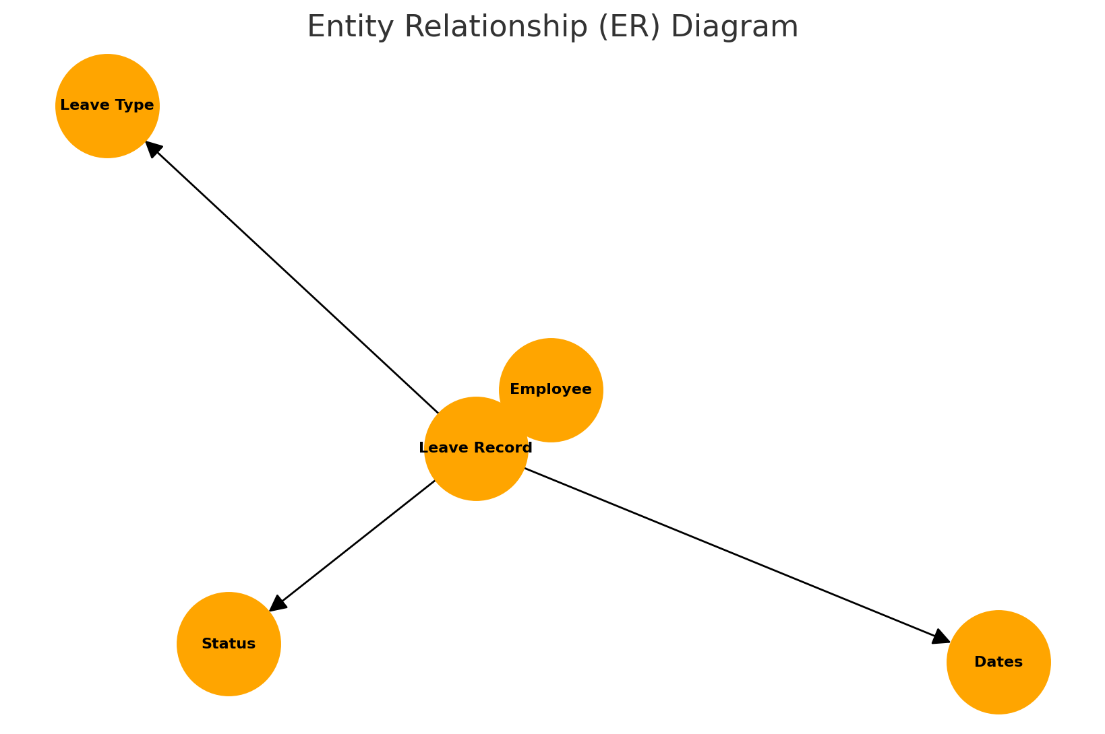
Illustrates relationships between Employee, Leave Records, Types, and Status.

Program Flowchart
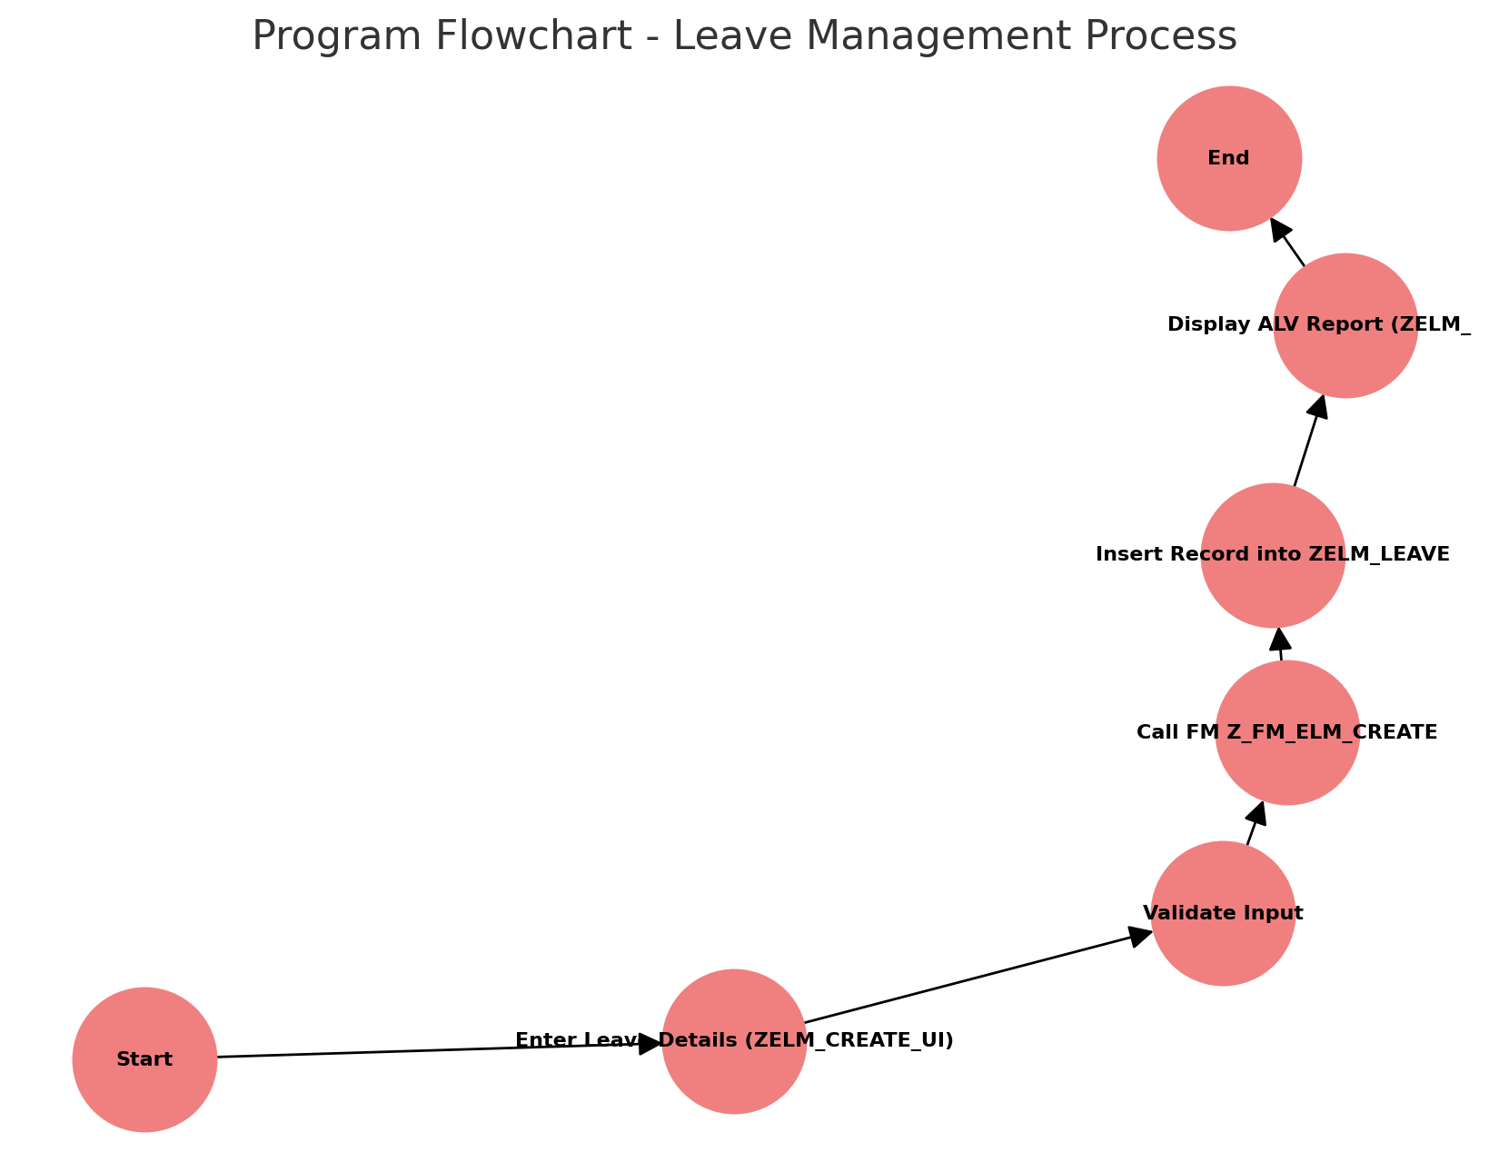
Flowchart visualizing main ABAP logic from user input to report generation.

H) Output Screenshots
Output 1
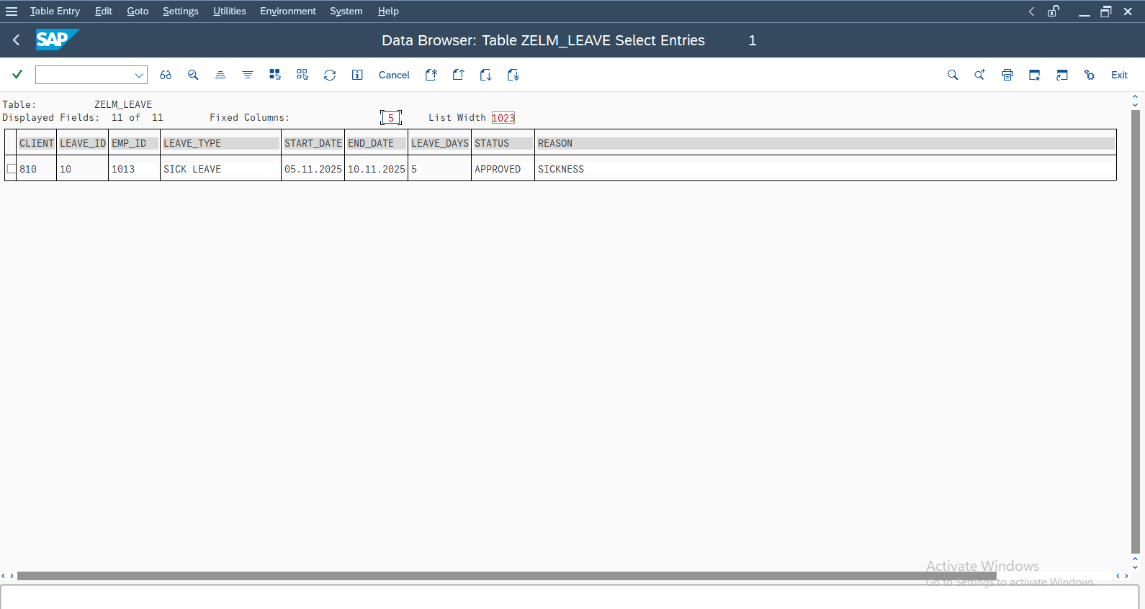
Output 2
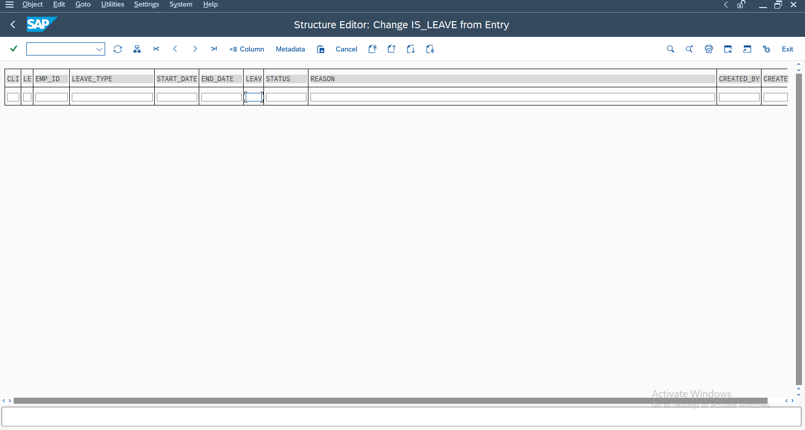

Output 3
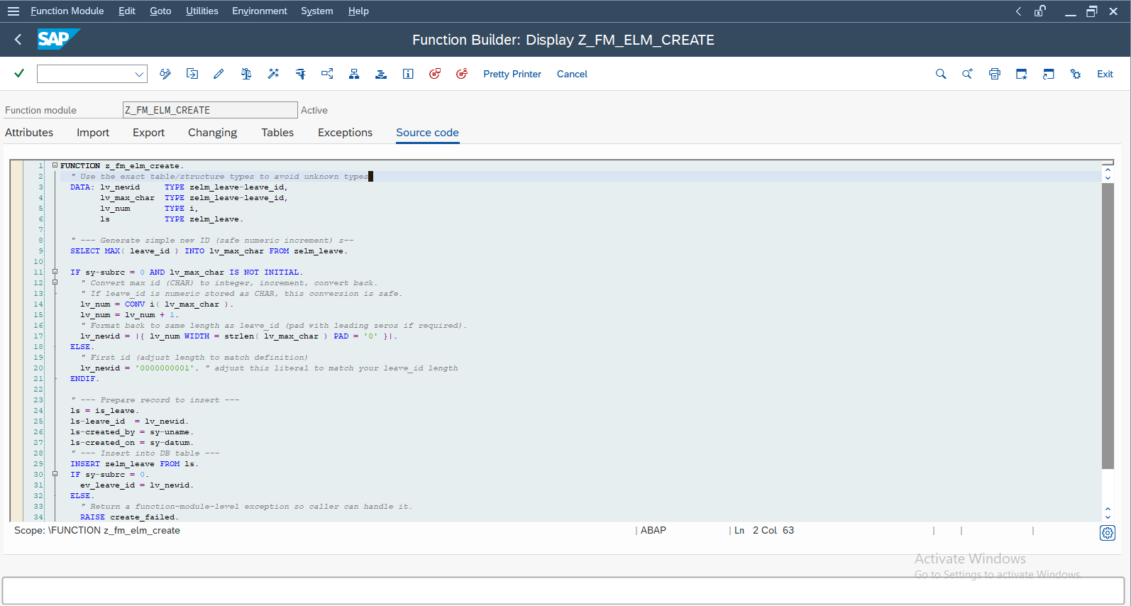
Output 4
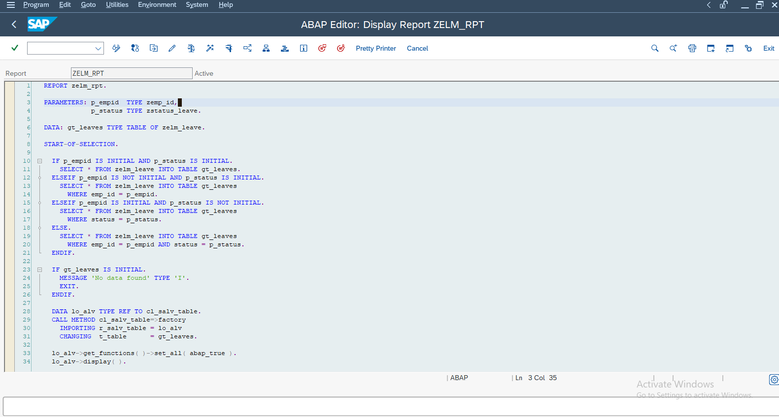

Output 5
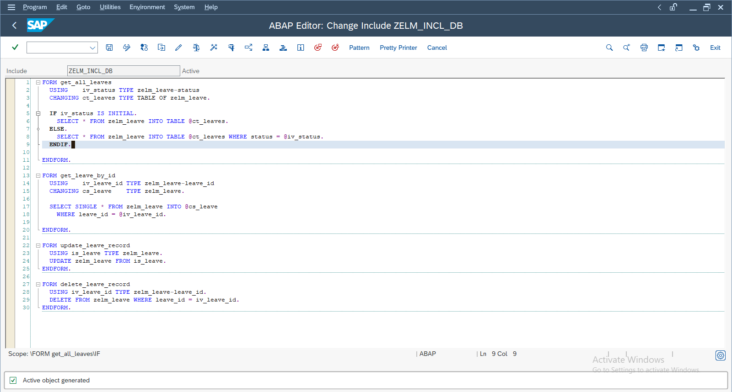
Output 6
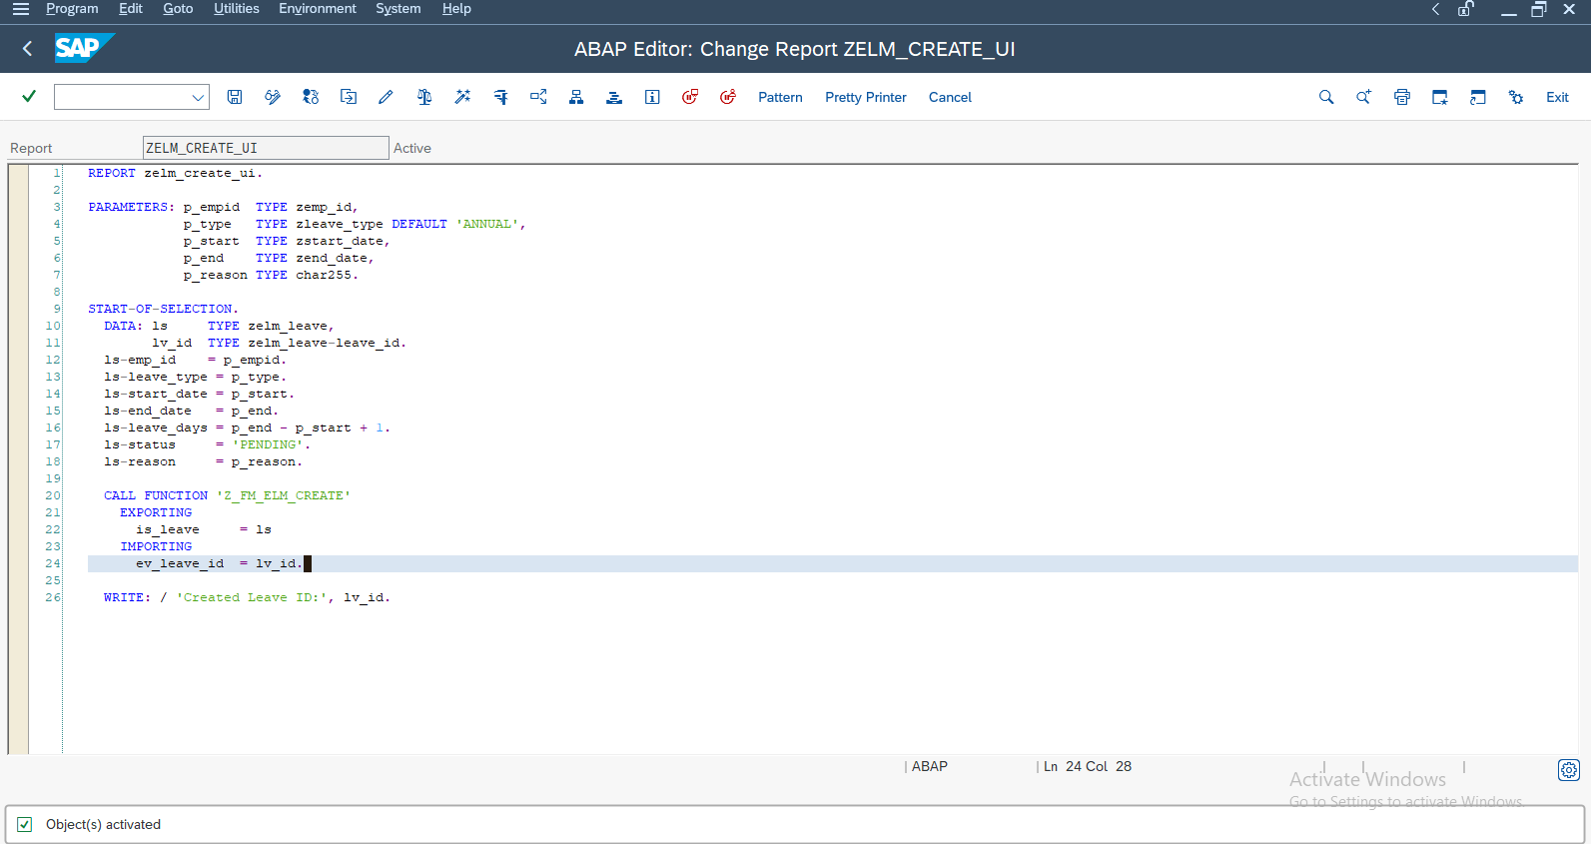

Output 7
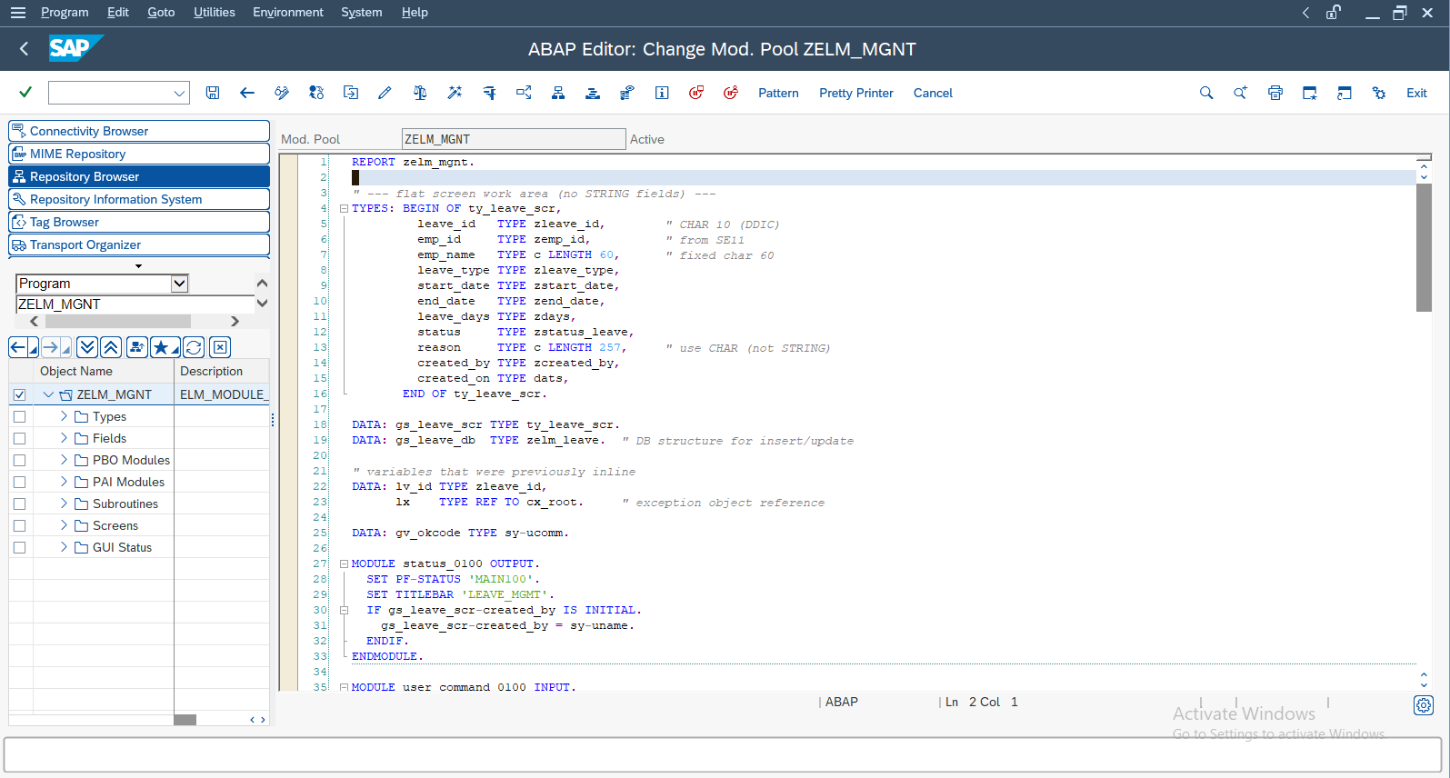
output 8
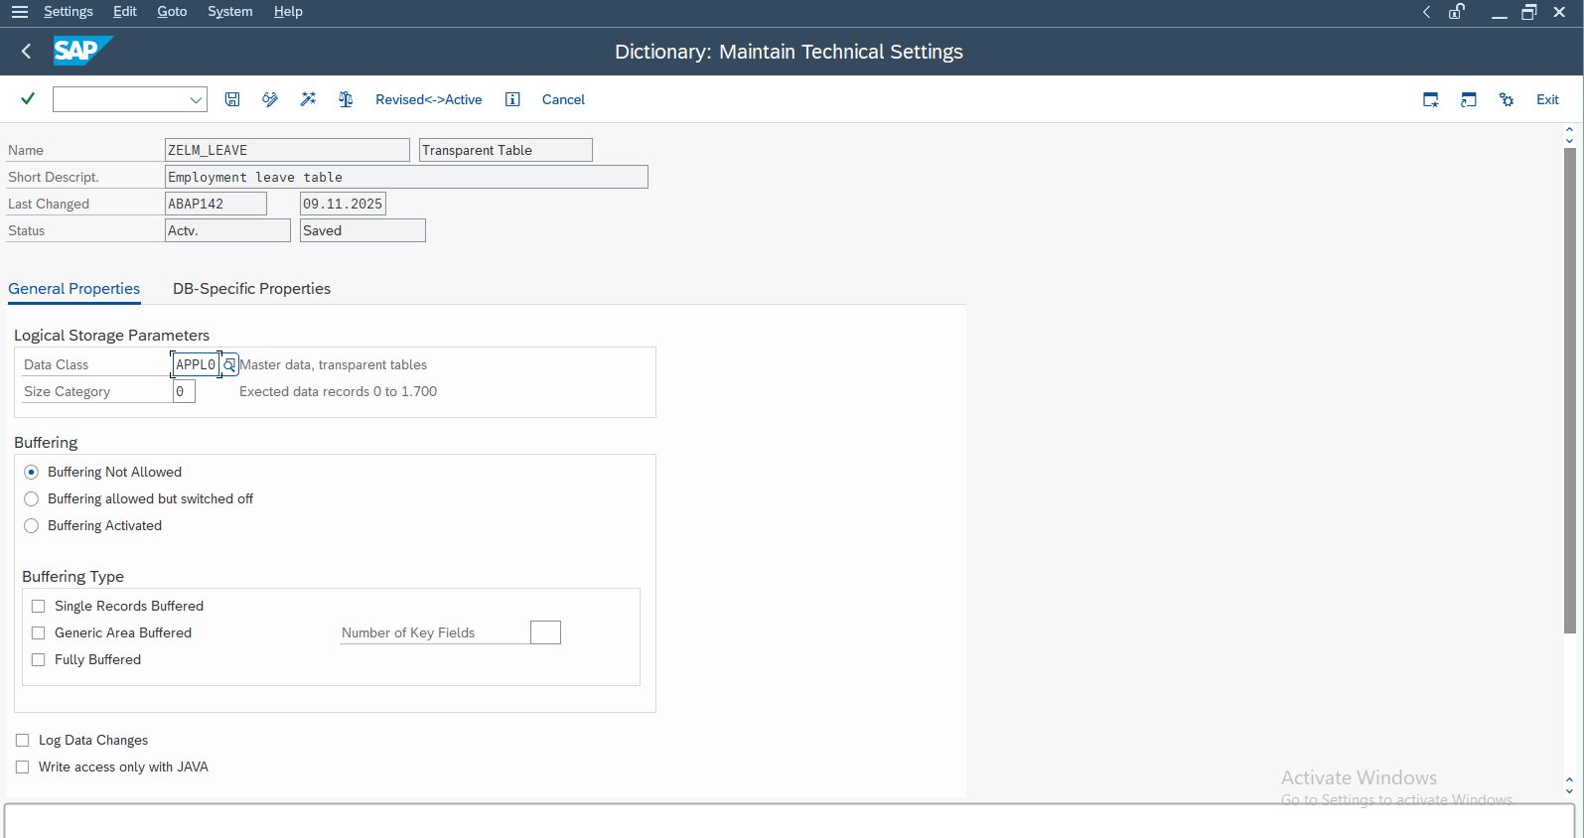

output 9
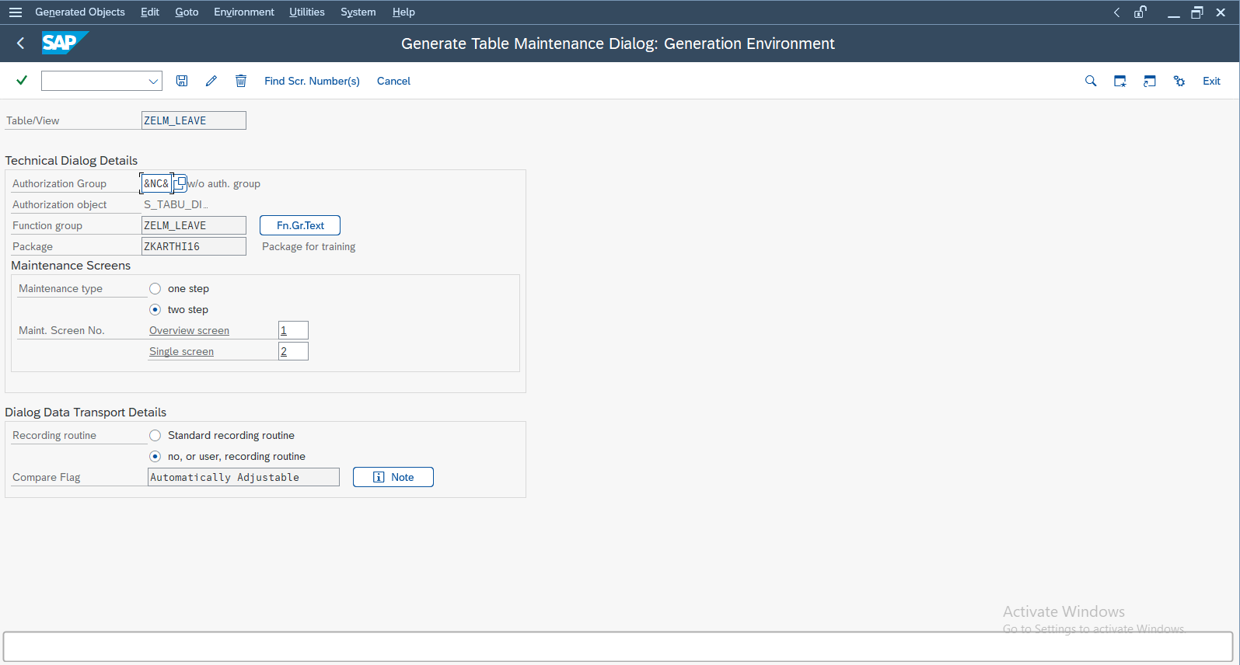
Output 10.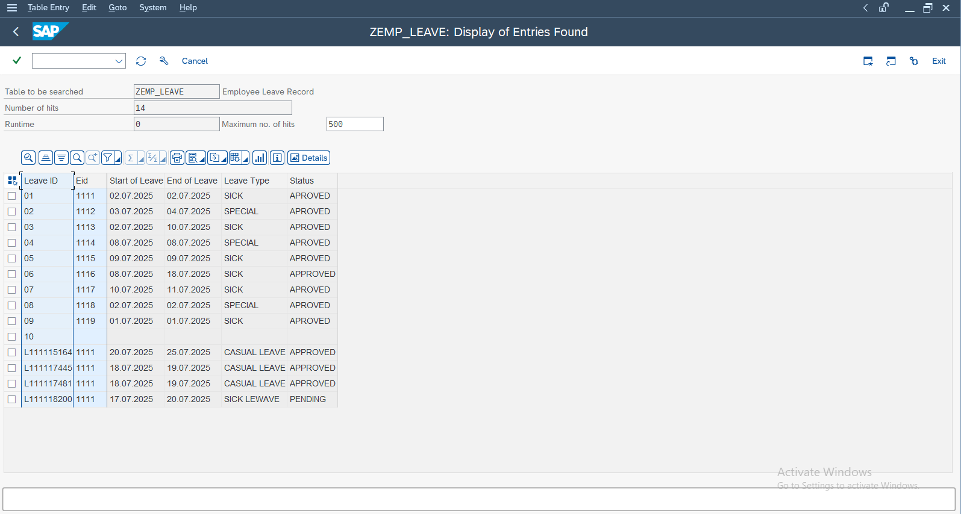

Output 11
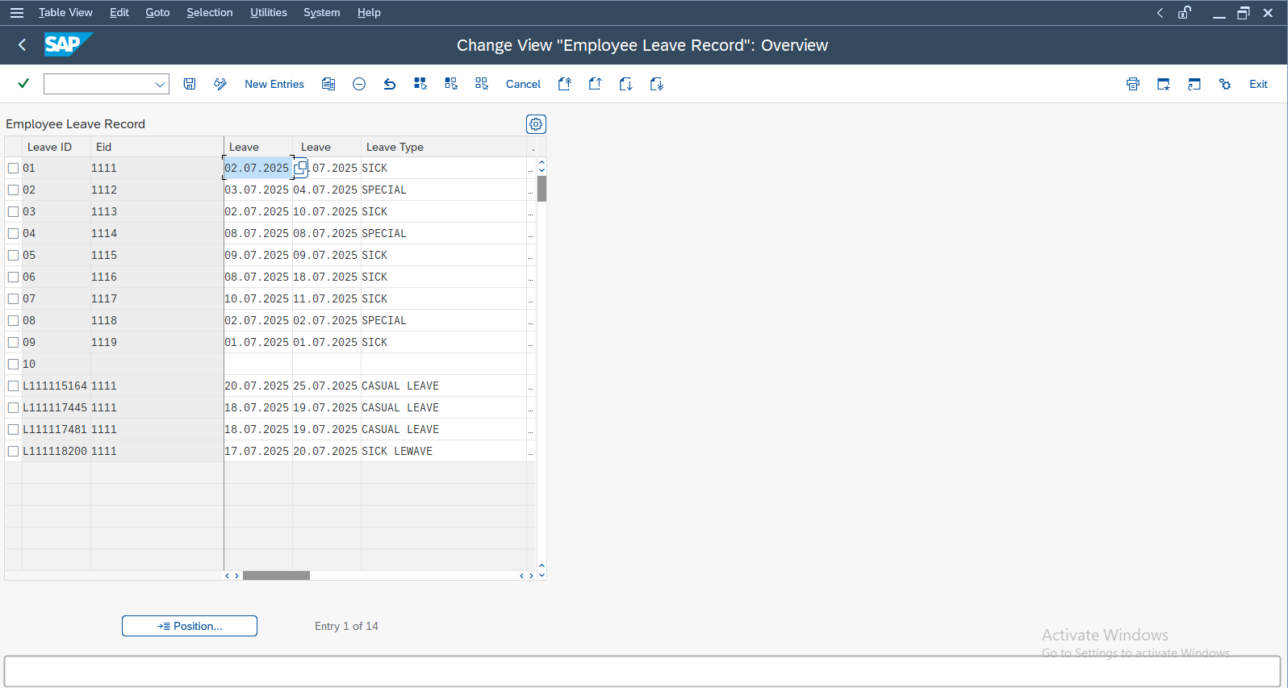

I) Future Enhancements
- Integration with SAP Smartforms for PDF outputs.
- Workflow-based approval processes.
- Role-based access control for different employee levels.

J) Conclusion
This project successfully demonstrates the implementation of a complete Employee Leave Management System in SAP ABAP.
All essential SAP ABAP components — Data Dictionary, Function Modules, Reports, and Module Pool Programming — have been integrated and tested.
The system provides end-to-end functionality for creating, managing, and reporting employee leave details efficiently.
K) Project Completion Summary
✅ Total Completion: 100%
All modules and functional units have been developed, tested, and validated successfully.
The project fulfills all the academic and practical requirements of a full-cycle ABAP application.

